Name: Pranali Sonawane
Subject: MCSA
Date: 17-12-2025
Lab 13: Disk Management

Server 1:
Tool Computer Management Storage Disk Management C Drive Shrink Create a E Drive
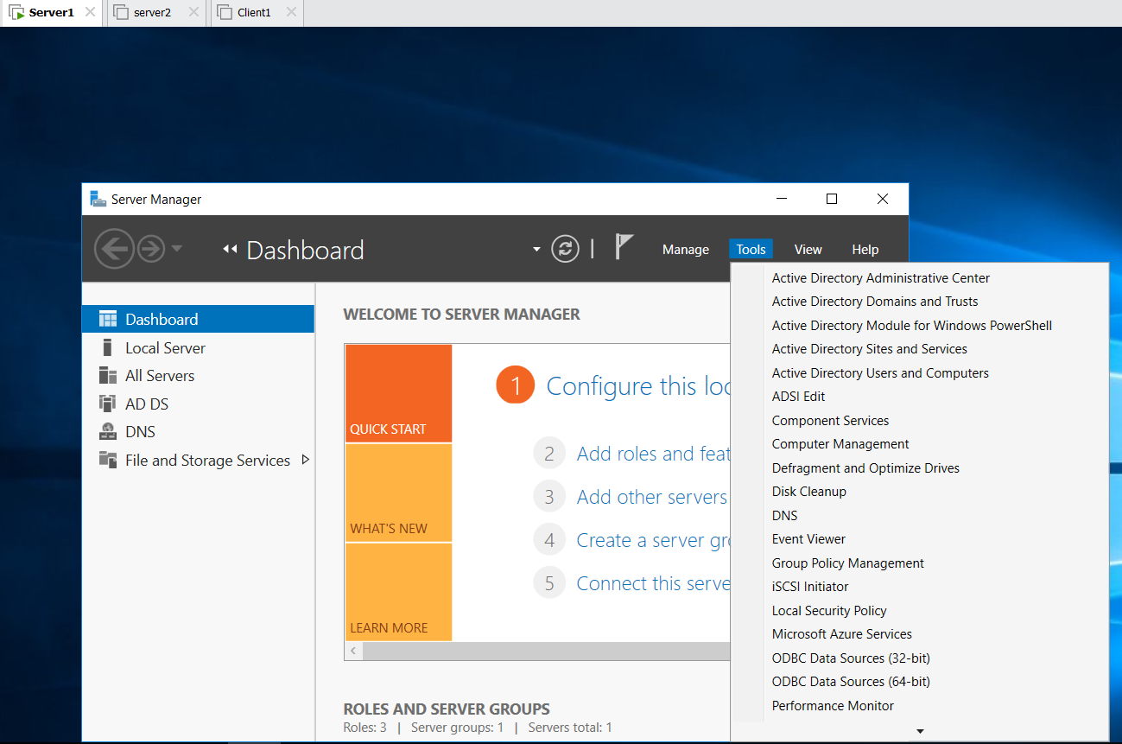
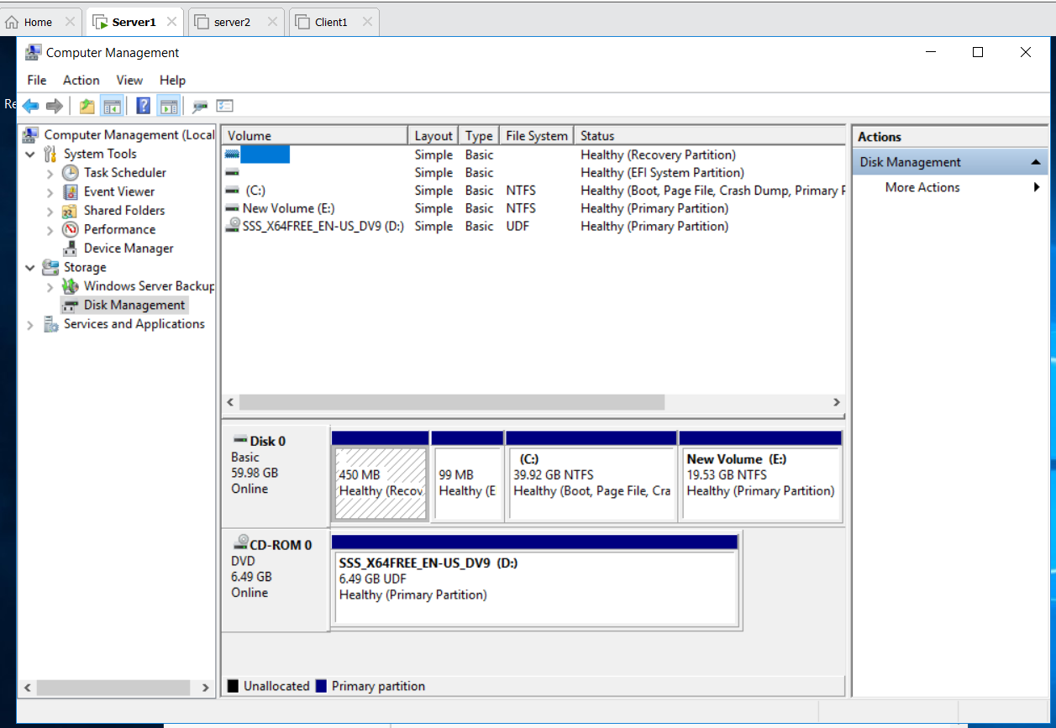
Server 1 Power Off Edit VM Settings Hard Disk create 4 Hard Disk
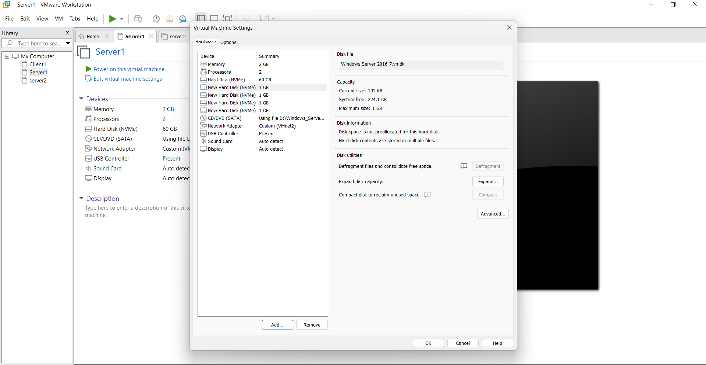

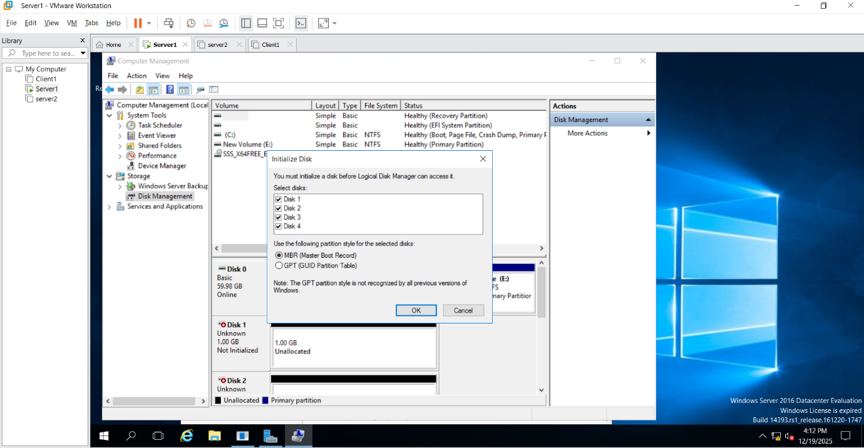
- Spanned Volume
Disk 1 new Spanned Volume Disk 1 give 300 MB
Disk 2 give 500 MB
Disk 3 give 700 MB
Disk 4 give 200 MB
Disk 1 Extend Volume Disk 1
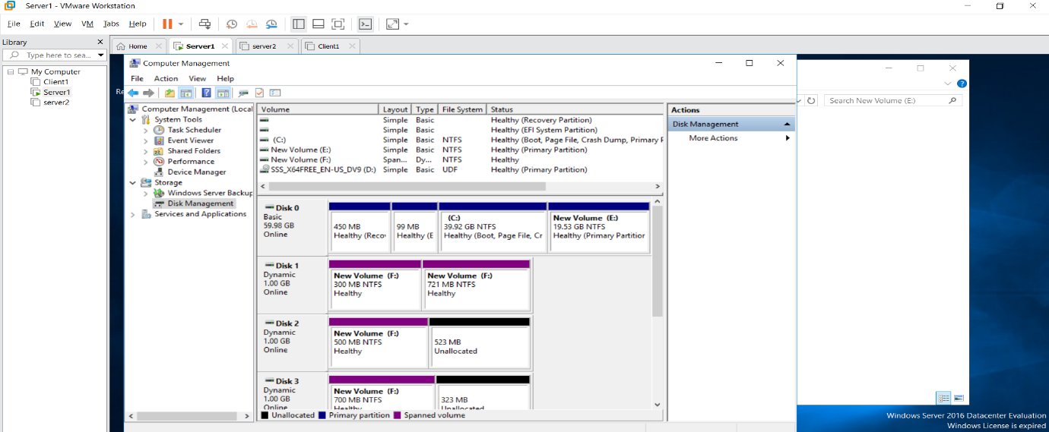

In Drive F Create test.txt
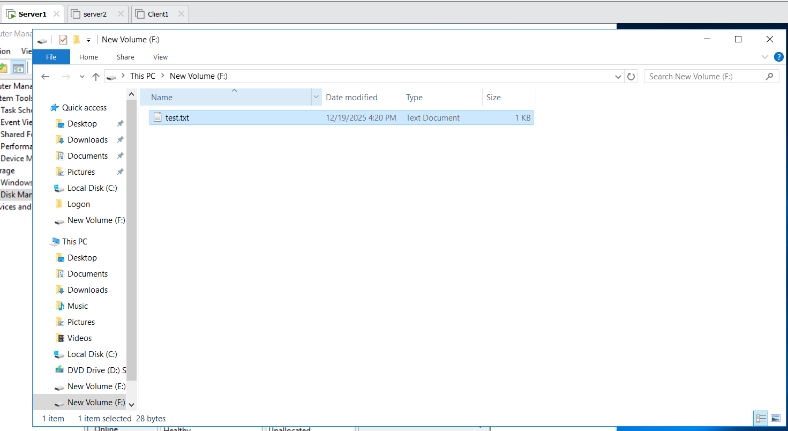
Disk 2 Offline then all Disk is failed This Pc has F drive is not Present
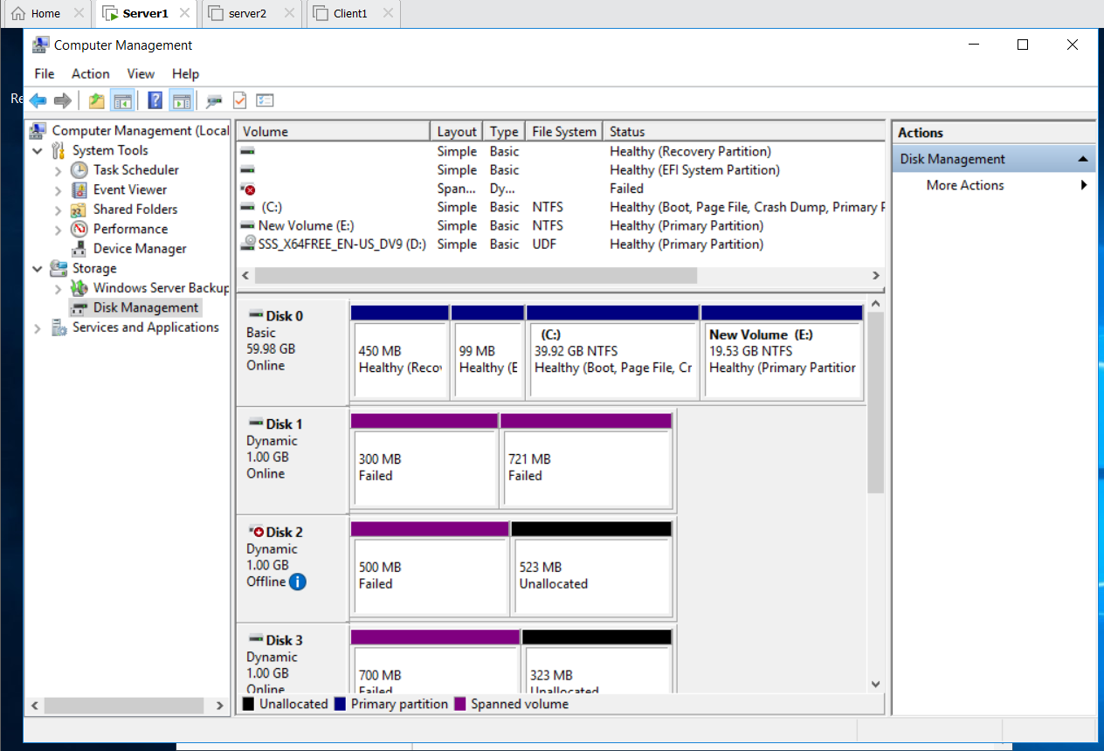

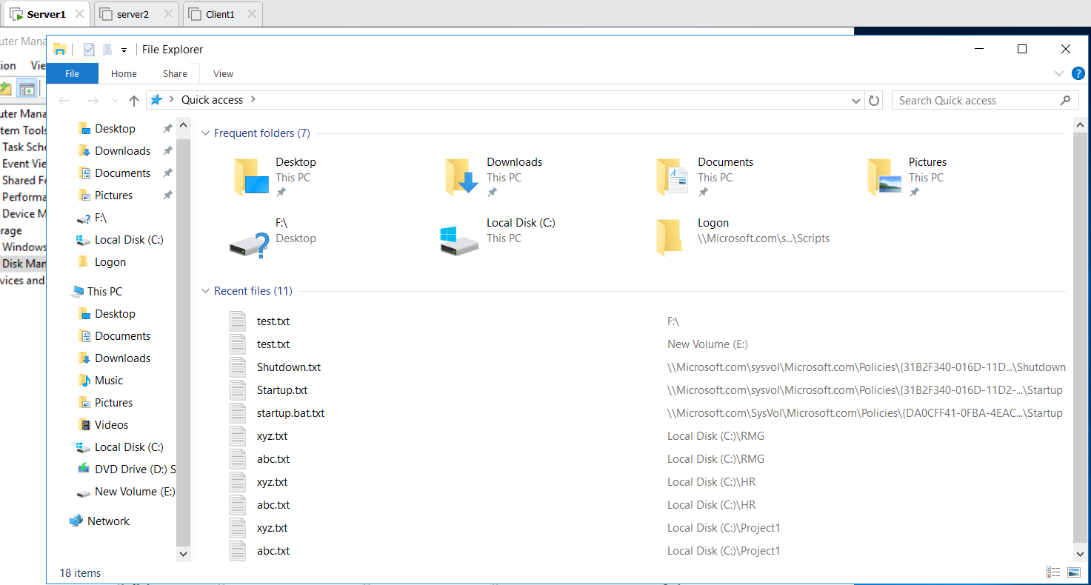
Mirrored Volume :
Only 2 Disk is Added in Mirrored Volume
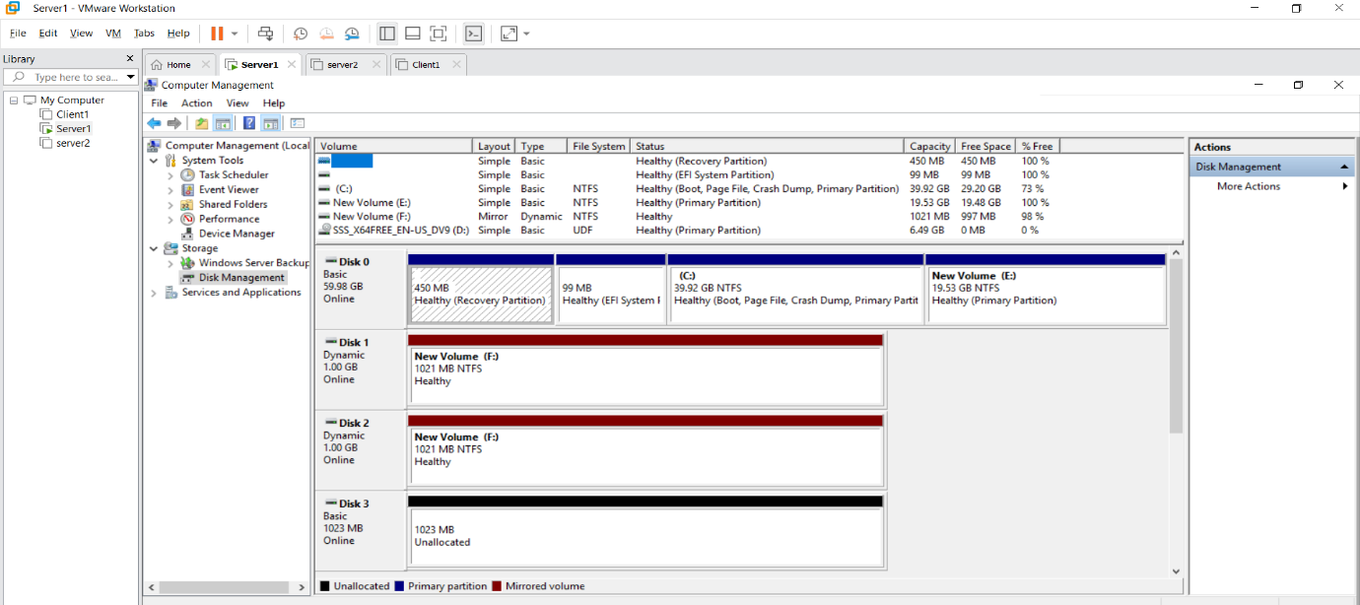
Disk 2 Offline then Disk 1 is failed This Pc has F drive is that txt file not Present
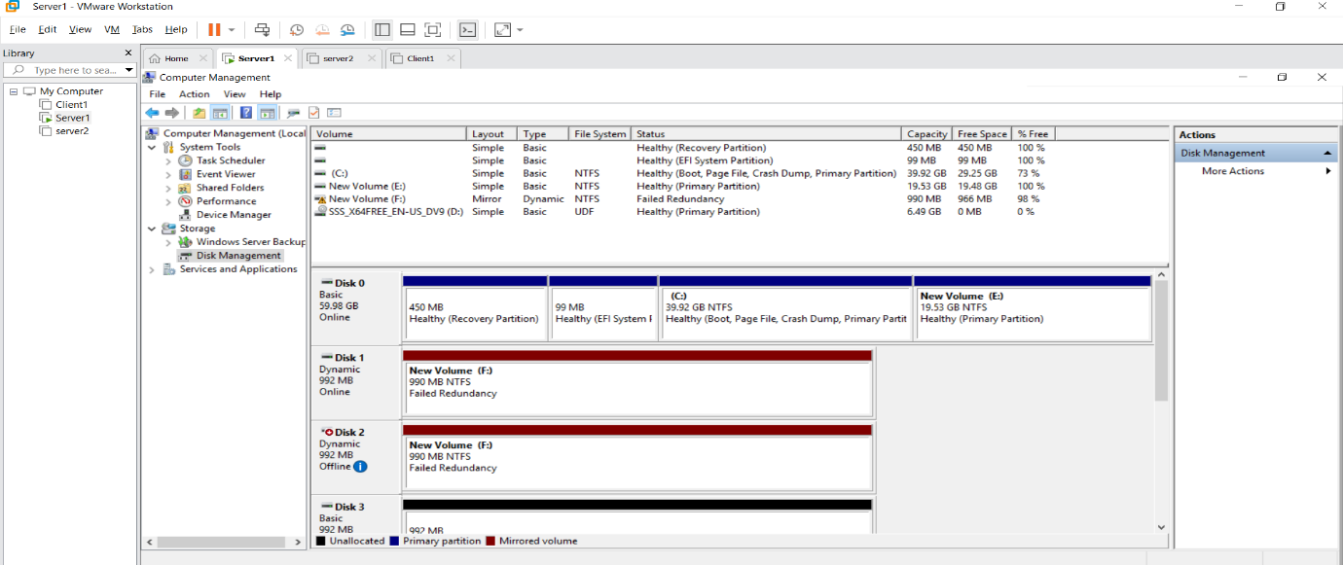
Disk 2 Online then foreign Import foreign group ok
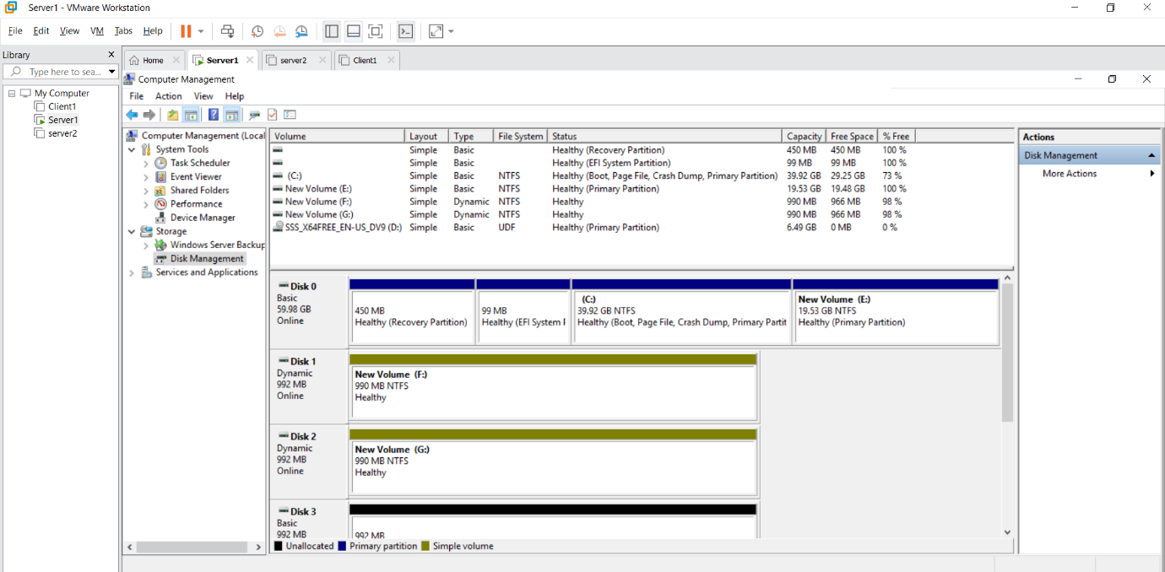
Raid 5 file:
Disk 2 Create Raid -5 Volume for all Disk
If two disks are offline, the F: drive will not appear in This PC.
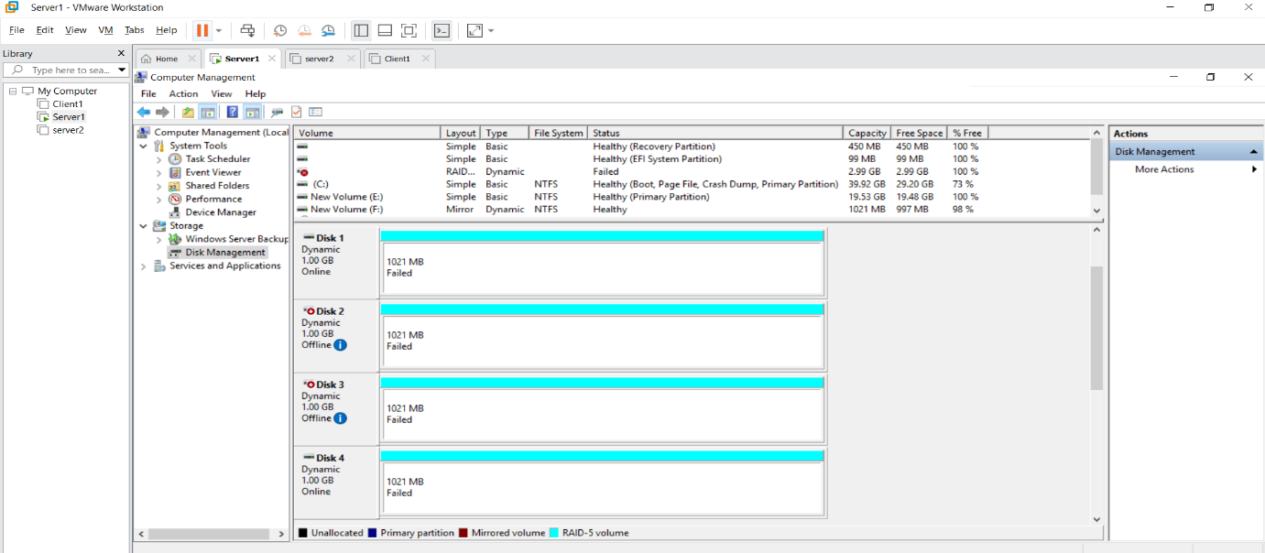

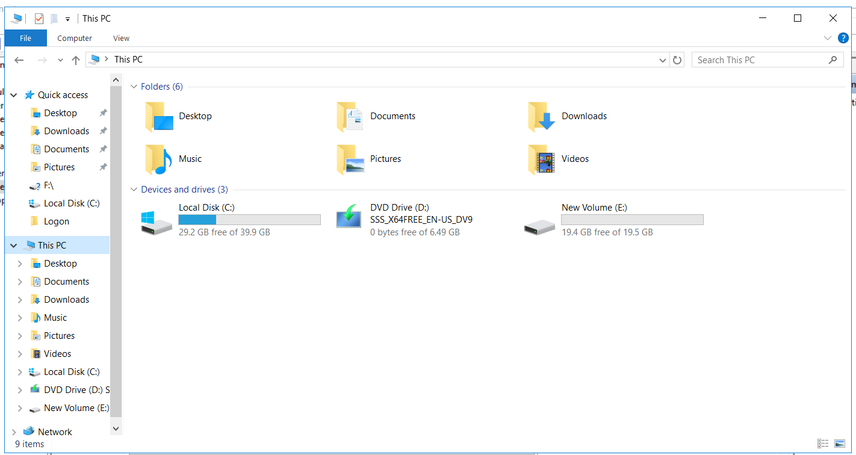
If one disks are offline, the F: drive will appear in This PC.

